Atitit 得到表 列名 列表

select *

from information_schema.columns

where table_name='s_member'

order by table_schema,table_name

获取主键可以。。

获取注释。。

取得数据库文档。。。

select table_schema,table_name,column_name,is_nullable,data_type,column_type,column_key,column_comment

from information_schema.columns

where table_name='s_member'

order by table_schema,table_name

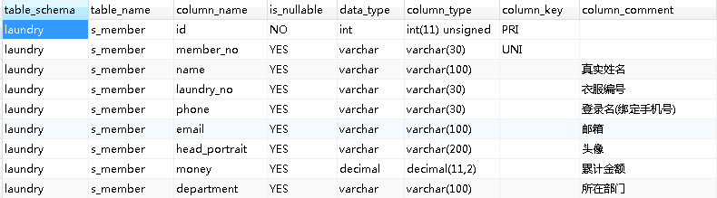

|  |  |  |  |  |  |  |  |  |  |  |  |  |  |  |  |  |  |  |
| --- | --- | --- | --- | --- | --- | --- | --- | --- | --- | --- | --- | --- | --- | --- | --- | --- | --- | --- |
| TABLE_CATALOG | TABLE_SCHEMA | TABLE_NAME | COLUMN_NAME | ORDINAL_POSITION | COLUMN_DEFAULT | IS_NULLABLE | DATA_TYPE | CHARACTER_MAXIMUM_LENGTH | CHARACTER_OCTET_LENGTH | NUMERIC_PRECISION | NUMERIC_SCALE | CHARACTER_SET_NAME | COLLATION_NAME | COLUMN_TYPE | COLUMN_KEY | EXTRA | PRIVILEGES | COLUMN_COMMENT |
| def | laundry | s_member | id | 1 |  | NO | int |  |  | 10 | 0 |  |  | int(11) unsigned | PRI | auto_increment | select,insert,update,references |  |
| def | laundry | s_member | member_no | 2 |  | YES | varchar | 30 | 90 |  |  | utf8 | utf8_general_ci | varchar(30) | UNI |  | select,insert,update,references |  |
| def | laundry | s_member | name | 3 |  | YES | varchar | 100 | 300 |  |  | utf8 | utf8_general_ci | varchar(100) |  |  | select,insert,update,references | 真实姓名 |
| def | laundry | s_member | laundry_no | 4 |  | YES | varchar | 30 | 90 |  |  | utf8 | utf8_general_ci | varchar(30) |  |  | select,insert,update,references | 衣服编号 |
| def | laundry | s_member | phone | 5 |  | YES | varchar | 30 | 90 |  |  | utf8 | utf8_general_ci | varchar(30) |  |  | select,insert,update,references | 登录名(绑定手机号) |
| def | laundry | s_member | email | 6 |  | YES | varchar | 100 | 300 |  |  | utf8 | utf8_general_ci | varchar(100) |  |  | select,insert,update,references | 邮箱 |
| def | laundry | s_member | head_portrait | 7 |  | YES | varchar | 200 | 600 |  |  | utf8 | utf8_general_ci | varchar(200) |  |  | select,insert,update,references | 头像 |
| def | laundry | s_member | money | 8 | 0 | YES | decimal |  |  | 11 | 2 |  |  | decimal(11,2) |  |  | select,insert,update,references | 累计金额 |
| def | laundry | s_member | department | 9 |  | YES | varchar | 100 | 300 |  |  | utf8 | utf8_general_ci | varchar(100) |  |  | select,insert,update,references | 所在部门 |
| def | laundry | s_member | plant | 10 |  | YES | varchar | 100 | 300 |  |  | utf8 | utf8_general_ci | varchar(100) |  |  | select,insert,update,references | 所在厂区 |
| def | laundry | s_member | is_delete | 11 | 1 | YES | int |  |  | 10 | 0 |  |  | int(1) |  |  | select,insert,update,references | 是否删除：1:为删除；2:已删除 |